LANDING ZONE

Landing Zone :

* A landing zone is a secure, scalable, and pre-configured environment in the cloud that provides a standardized foundation for deploying applications and workloads.
* A well-designed cloud landing zone is a prerequisite for a successful cloud migration or adoption strategy.

Key components :

* Identity and access management (IAM): Defines user roles, permissions, and policies to ensure that only authorized users can access sensitive resources.
* Resource organization: Uses a clear hierarchy to logically structure cloud resources, such as separate accounts or subscriptions for different applications or business units.
* Networking: Sets up a secure and scalable network architecture, including virtual networks, subnets, and rules for connectivity between cloud resources and on-premises systems
* Security and governance: Enforces compliance and security standards through policies, controls, and automation.
* Monitoring and logging: Establishes tools for auditing resource activity, tracking performance, and collecting logs for analysis.
* Cost management: Enables budget allocation and visibility into spending patterns by segregating workloads.
* Infrastructure as Code (IaC): Uses templates, such as Terraform, to automate the deployment of the landing zone, which makes the setup repeatable and consistent.

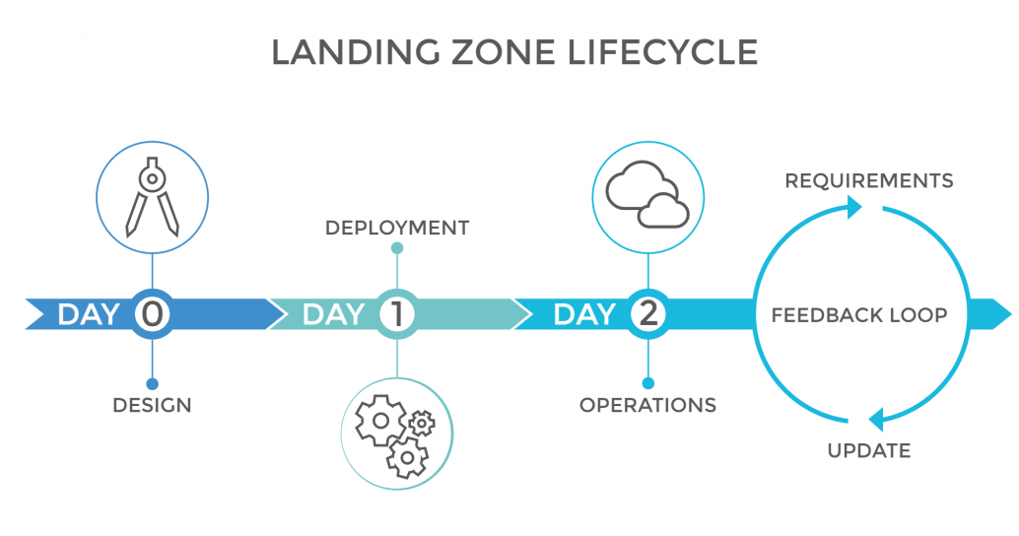

Landing Zone in AZURE :

* An Azure landing zone is a secure, multi-subscription cloud environment that is the foundational component of the Cloud Adoption Framework (CAF) for Azure.
* It provides the building blocks for an organization to manage, govern, and scale its applications and workloads effectively and securely.

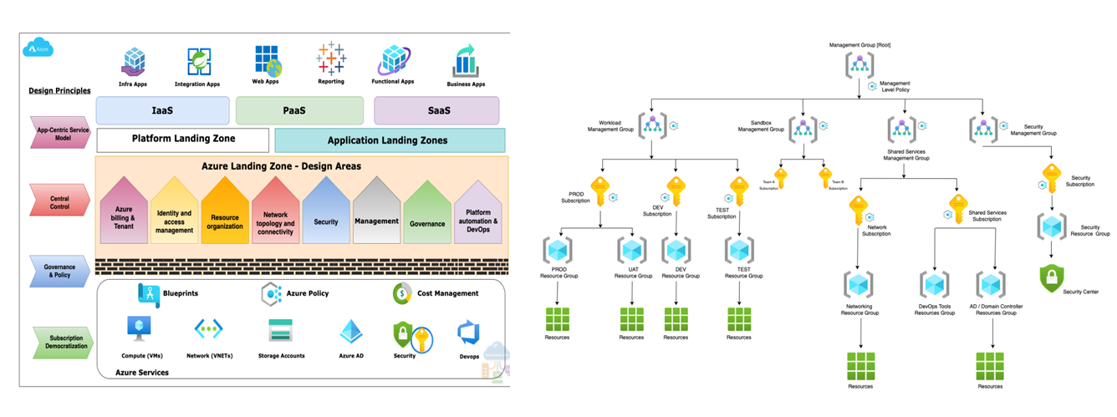

Landing Zone in AWS :

* An AWS landing zone is a secure, multi-account AWS environment that is the foundational starting point for deploying and managing workloads. It is a scalable environment that incorporates AWS best practices for security, networking, governance, and identity.

